申请EAN·UCC编码须知
Note for EAN·UCC Company Prefix Application
EAN·UCC 编码系统广为全球129个国家及经济体系超过九十万家企业採用。美国统一代码委员会(UCC)已定立明確目標，於2005年1月前，所有其会员可同时接纳 13数位的EAN/UCC-13编码和UPC编码。届时所有北美洲/加拿大的零售商將可於销售点扫瞄EAN·UCC编码，读取所需资料。倘 贵公司於美国/加拿大的客户现阶段未能採用13数位的EAN/UCC-13编码， 贵公司可向本会申请UCC编码。
EAN·UCC Numbering System is adopted by nearly 900,000 corporates across 129 countries/economies. The UCC has established a sunrise date for its members to accept the 13-digit EAN/UCC-13 as well as the UPC at the point-of-sale no later than January 2005. All retailers in North America or Canada would be required to be able to scan and store EAN·UCC number. If your US/Canada customers affirm that they cannot accommodate the 13-digit data structure of EAN/UCC-13 at the moment, your company can apply a UCC Company Prefix from the HKANA.
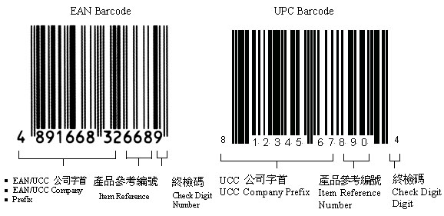
可用以编配EAN/UCC公司编号之幸运号码
LUCKY NUMBERS FOR EAN/UCC COMPANY NUMBERS
EAN/UCC公司编号一般依顺序而分发，本会亦可按申请公司之要求编配幸运号码，有关之手续费用需於申请时一次缴交，详情如下:
The EAN/UCC Company Prefixes are issued on sequential basis, however, a company can choose its own specific Lucky Number for an additional one-time payment. The HKANA will assign a Lucky Number as the EAN/UCC Company Prefix of a member according to the price listed below:
香港瑞丰会计事务所 是一家具有10多年品牌的国际权威性机构、拥有注册会计师、执业律师、财务师及高级管理顾问组成的强大团队。总部位于中国香港。在全球30多个国家地区设 立商业网络，为客户组建成立香港公司、海外离岸公司、商业财务管理、企业上市融资、记帐报税审计、知识产权代理、海外合理避税、法律文书公证、使馆领馆认 证、贸易投资顾问等方面提供最佳的方案。

